CAMBODIA

Cambodia boasts a rich culture with its many ancient temples and impressive natural scenery, such as the empty beaches, mighty rivers and the remote forests.
At the present, more of Cambodia is open to visitors than any other time in decades. As well as the famous temples at Angkor near Siem Reap, there are many other beautiful places to discover. The empty beaches in Sihanoukville on the South Coast of Cambodia, are a great place to relax and enjoy the sun. You may choose to visit here on the way back to Phnom Penh, stopping at Kampot and Kep on the way.
Many of the provincial towns offer a combination of colonial architecture, sleepy riverside locations and some very friendly local people. The best of these to visit are Kompong Cham and Kompong Chhnang, and probably the most satisfactory is Battambang.
Situated on the Indochina peninsula, Cambodia is bordered by Thailand, Vietnam and Laos, with its south-western coast looking out over the Gulf of Thailand

Cambodia is administratively divided into 20 provinces, with two major cities: Phnom Penh, the capital, and Sihanoukville, a large seaport in the south.

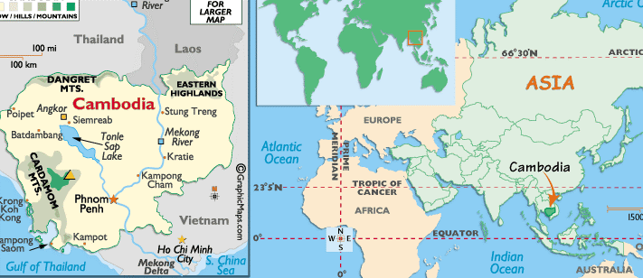

VISA: The visa should be obtained prior to arrival in the country.

GETTING THERE:
By Air: there are no direct flights from India but there are direct flights to the capital, Phnom Penh from Bangkok, Hanoi, Ho Chi Minh City, Hong Kong, Kuala Lumpur, Singapore, and Vientiane. From Phnom Penh, one can take direct flights to Siem Reap (Angkor).
Direct flights exist from Bangkok to Siem Reap as well.
International Gate Ways
- Phnom Penh International Airport
- Siem Reap International Airport
- Sihanoukville Port
- Airport Tax: (subject to change)
International Airport:
- Foreigner: USD25
- Cambodian: USD18
Domestic:
- Foreigner: 6USD
- Cambodian: 5USD

By Road: Cambodia can also be reached by road from Thailand and Vietnam.
By Waterway: Another exotic way to reach Cambodia is by river boat or sea cruise.

CLIMATE:
Nov-Feb, cool/dry
Mar-May, hot/dry
Jun-Aug, hot/wet
Sep-Oct, cool/wet
The ideal months to be in Cambodia are December and January, when humidity is bearable, temperatures are cooler and it is unlikely to rain. From February onwards it starts getting hot, and April is unbearably so. The wet season (from May to October), though very soggy, can be a good time to visit Angkor, as the moats will be full and the foliage lush - but steer clear of the northeast regions during those months, as the going gets pretty tough when the tracks are waterlogged.
Cambodia falls into a tropical region and as such enjoys high temperatures year round. Western tourists may find the extremes of temperature in the dry season (Nov-Apr when the mercury climbs to around 40°C) a bit too much, while the monsoon hits the country in May and lasts until October.
The monsoon can be a spectacular time to visit. Most falls as extremely heavy rainfall in cloudbursts accompanied by thunder and lightning, occurring each afternoon for around an hour. However, the Monsoon can make things difficult for tourists, many trekking areas become impassable, and the increased force of the Mekong flowing into the Tonle Sap river actually reverses the flow of the lesser river - backing it up to the Tonle Sap and doubling the area of the lake.
The best time for most tourists to visit is at the end of the rainy season, from Oct-Jan. The land appears at its lushest and temperatures are yet to hit the summer highs, being still warm but not excessively so.

CLOTHING:
Comfortable lightweight clothing in natural fabrics as cotton is most suitable for travelling to Cambodia. The dress code is casual as in most parts of the tropics but it is advisable to cover arms & legs in the evening against biting insects. A light weight rain coat is a good idea in the rainy season

TIME:
Cambodia is 1 hour 30 minutes ahead of India

CURRENCY:
The official currency of Cambodia is the Riel (CRI), abbreviated by a lower-case 'r' written after the sum. Notes are in denominations of 100,000, 50,000, 20,000, 10,000, 5000, 2000, 1000, 500, 200 100. The US$ are widely used and accepted and it is advisable to bring some with you. Foreign currencies can be changed at hotels, airports or markets. Commission is generally not charged at the market moneychangers so they tend to be cheaper, than the alternatives
Most places deal in US Dollars particularly for items more than CRI10000 in value. It is advisable to carry a small amount of riel with you for small purchases, but the balance of your cash should be in dollars

LANGUAGE:
Khmer, secondary languages are English and French

ELECTRICITY:
The electrical current is 220 volts, AC 50Hz in Phnom Penh but in other areas, it is 110 Volts. One must be prepared for unstable power supply.

TIPPING:
Tipping isn’t obligatory but is widely practiced in hotels and restaurants in addition to the service charges shown on bills

GETTING AROUND:
By Air: The easiest way of getting around Cambodia, considering the state of the country's roads, is via internal flights. There are several domestic airlines, including Royal Phnom Penh Airways, Siem Reap Airways and newcomer President Airlines.
Flying is the quickest but expensive way of getting to places like Angkor, Battambang, Ratanakiri, Koh Kong, Stung Treng and Mondulkiri.
By Waterways: With some 1900km of navigable waterways to utilize, boats play a major role in getting around. The most popular services operate between the capital and Siem Reap - the express service cuts the journey time down to a mere four hours. Fast boats also head up the Mekong to Kompong Cham, Kratie and Stung Treng.
By Taxis: An effective local bus network makes travel to sights around Phnom Penh much easier than driving, particularly as cars can only be hired with a driver. Taxis are more common in the cities, and cycles and motos (small motorcycles) can be flagged down for short hops.
By road: To Sihanoukville from Phnom Penh takes around four hours whereas the train takes up to 13. In spite of this, more and more visitors are taking advantage of the incredibly cheap train fares, but mostly only for shorter distances.
By train: Until relatively recently foreigners were not allowed on the trains, but that particular ban is no longer enforced. You should note that foreigners do pay more than locals for their fares (usually double), but the rate is still so low that there's little point making a fuss about it.
There are only two lines, both extending from Phnom Penh. As well as the southern route to Sihanoukville there is another track running north to Battambang.
The standards onboard are not very high. Foreigners at least will be ushered to one of the carriages with seats, the bulk of the train is often made up of flatbed or covered freight wagons, upon which people sit. Trains stop at towns and villages to allow salesmen and food vendors onboard.
Whether wanting to catch a train or not it is worth visiting Phnom Penh's train station. This bright yellow building is a great example of French colonial architecture.
By bus: Buses and coaches are the mainstay of the national public transport network. They range from super-modern vehicles to ones that by all rights should have been scrapped years ago. All are privately operated from local bus stations. You are advised to try to buy your ticket in person as far in advance of travel as possible.
Air-conditioned buses from Phnom Penh to Sihanoukville run regularly from Psar Thmei, the Central Market. Buses to Ho Chi Minh City in Vietnam also depart from here
• You should note that it is most convenient to travel everywhere in a city via taxi, motodop or bicycle rickshaw.
• Prices are low enough to make it practical and seeing as most places seem to be navigated by name rather than address it's the easiest way to locate anything.
• If you're going to the Killing Fields, take a taxi rather than a motorbike, as the road is very potholed and dusty.
The following table provides approximate driving distances between selected cities.
From Phnom Penh to: | Km | Miles
Kampong Saom | 180 | 112
Kampot | 130 | 81
Battambang | 265 | 165
Kampong Chhnang (Tonle Sab lake) | 80 | 50
Kratie | 340 | 210
Aranyaprathet (Thai border) | 370 | 231
Bangkok (Thailand) | 645 | 405
Svay Rilng (Cambodia border) | 107 | 66
Ho Chi Minh (Vietnam) | 240 | 150
Muang Khong (Laos border) | 580 | 360

CITIES:

PHNOM PENH:
Cambodia's modern capital is a vibrant bustling city nestling majestically on the banks of the confluence of the two mighty rivers of the Mekong and the Tonle Sap. The area surround the Royal Palace has magnificent Khmer towers and remains particularly delightful. There are many open spaces and parks in the center, which the locals use for recreation and relaxation. Pedaled rickshaws, called cyclos, still ply the streets as in colonial days and provide an excellent opportunity for sightseeing and people watching as well as the taxi service.
The crumbling colonial architecture makes an attractive backdrop to bustling streetside cafes and the redeveloped riverfront precinct - a particularly lively part of town on Friday and Saturday nights. The city has several impressive Wats (temple-monasteries), including Wat Ounalom (headquarters of the Cambodian Buddhist patriarchate), Wat Phnom (the hilltop pagoda which gave the city its name) and the newly painted Wat Lang Ka. Pride of place goes to the spectacular Silver Pagoda, one of the few places in Cambodia where artifacts embodying the brilliance and richness of Khmer culture were preserved by the Khmer Rouge. The National Museum is another highlight, with outstanding displays of Khmer crafts.

MUST SEES:
The Royal Palace:
The official home of King Norodom Sihanouk, the Royal Palace is a grand building in keeping with its status.
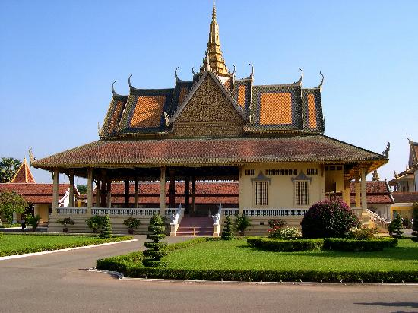

The predominant colours are yellow, representing Buddhism, and white, representing Brahmanism. As it is the home of the King, much of the palace complex is off-limits, but visitors have access to the Chan Chaya Pavilion, from where the King and head of state deliver their speeches to the nation. You can also see the impressive Throne Room and the quirky iron pavilion of Napoleon III, a gift to King Norodom in 1876.
The palace grounds are open to the public.
Open: 07h00-17h00. Additional charges for cameras and videos are payable. Note that a guide is needed for some parts of the palace at an additional charge

Silver Pagoda:
Also known by the name "The Temple of the Emerald Buddha", the Silver Pagoda is part of the palace complex. The entire floor of the pagoda is covered with silver tiles, over 5,000 of them, each more than 1kg in weight.
The temple is home to a host of other treasures including glittering Buddhas made of gold, silver, jade and of course the exquisite Emerald Buddha. Many of these ancient statues are studded with precious stones. Along the walls of the compound a mural depicts the tale of the Ramayana, while outside the temple various stupas house the ashes of past royalty.
Open: 07h30-11h00 & 14h30-17h00.

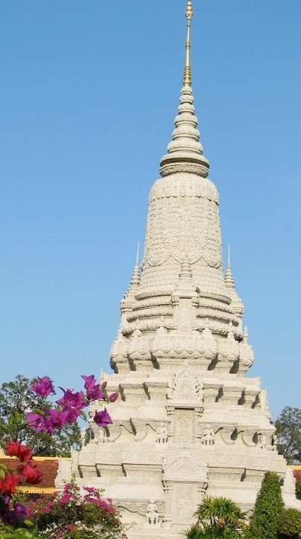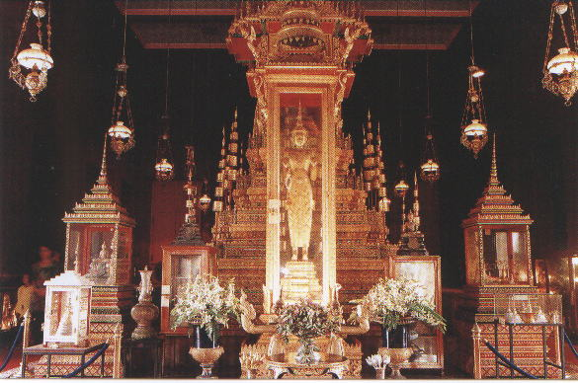

National Museum:
This deep-red building built in traditional Khmer pagoda style looks far more venerable than its age suggests. Only built in 1913 the museum is today home to thousands of cultural artefacts, some dating back to the 4th century. The collection also contains many Angkorian statues, which miraculously escaped damage or destruction during the Khmer Rouge years. These include rare sculptures of some of the kings of that time - most notably Jayavarman VII, considered the greatest of the Angkor leaders.
The museum is inhabited by thousands of bats, which, around sunset, when the museum guides stir them into action, take flight in droves, making for a remarkable sight. The courtyard in the centre of the complex, complete with ponds, pagodas, and formal plantings is an incredibly peaceful sanctuary from the city outside, and from the squeaking of the bats that is a constant companion to any tour of the galleries.
Open: 08h00-11h00 & 14h00-17h00
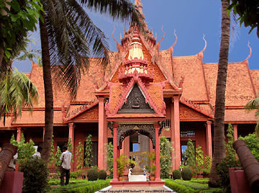

Tuol Sleng Genocide Museum:
Cambodia's tragic history draws visitors to this former school that became a torture centre for the Khmer Rouge during the 1970s. Nowadays Tuol Sleng serves as an enduring reminder of the genocidal madness of the Pol Pot regime and the horrors of war. It is a must visit for anyone, but be warned that the graphic description of the atrocities perpetrated here can be distressing.
An incredible 17,000 men, women and children were brought here to face Pol Pot's torturers before being taken to the Killing Fields. Each of the small classrooms contains a rusting bed where the torture was carried out. Each room also contains a photograph of the last victims found in 1979 as the liberating Vietnamese army marched on Phnom Penh.
Macabrely the Khmer Rouge documented and photographed their victims meticulously - as can be seen in the rooms downstairs.

The Killing Fields:
For those that survived the torture at Tuol Sleng, Choeung Ek, 9km outside of the capital, was their final destination. To Westerners these are better known as "The Killing Fields", having been the subject of the 1984 Oscar-winning film of the same name that told the true story of the horrors that were perpetrated here.
At first glance, the grassy area looks innocuous enough, but wandering around the fields reveals the pits where mass graves were found. Shreds of prisoners' clothing from the recent exhumations can still easily be seen, poignant reminders of the inhumanity of the killings. Beyond the pits that are uncovered lie many more that have been left untouched - permanent graves to the thousands that occupy each one.
The sheer scale of the site is a stunning indictment against the brutality of the Khmer Rouge. People brought here were clubbed to death to save ammunition before their bodies were piled into the vast pits, one on top of another. The central memorial stupa contains thousands of skulls - an estimated 8,000 of them - recovered from the unmarked graves. The Killing Fields of Choeung Ek are a grisly reminder of the atrocities committed by the Khmer Rouge. Some 17,000 people were killed here, just 15km south-west of the city centre, and more than 8000 skulls, arranged by sex and age, are visible behind the glass panel of the Memorial Stupa, which was erected in 1988.

SIEM REAP:
Nestled between rice paddies and stretched along the Siem Reap River, the small provincial capital of Siem Reap Town serves as the gateway to the millennium-old temple ruins of the Khmer Empire. Designated a World Heritage Site by UNESCO, the encompasses dozens of temple ruins including Bayon, Banteay Srey and the legendary Angkor Wat whose artistic and archaeological significance and visual impact put it in a class with the Pyramids, Machu Pichu and the Taj Mahal. Unlike many other world class monuments, the ruins of Angkor are as yet unspoiled by over-development. Though the major temples are relatively well visited these days, it is still possible get away from the crowds, to explore the area and discover Angkor.
The town of Siem Reap, the provincial capital, is a pleasant sleepy backwater serving as a base for visitors to the ancient capital of Angkor. Though not essential, a well informed professional guide will enhance any tour, providing insight and history often not available in guide books. Many of the temples and best viewed at different times of the day due to their geographical orientation and the angle of the sun.
Accommodation and food can be found in the town of Siem Reap, only a few km from the temples.

Temple of Angkorvat
Cambodia's greatest attraction has to be these breathtaking structures outside the town of Siem Reap in the north-west of the country. Made up of numerous complexes the entire site encompasses an area of 200 square kilometres which would take an age to explore fully. However, the main temples of Angkor Wat and Angkor Thom are within easy touring distance of one another.
For hundreds of years these temples lay forgotten, and in many places were reclaimed by the surrounding forest. It was only in the 1800s that French naturalist, Henri Mouhot, brought them to the world's attention. Looting became a huge problem and continues to this day, with many of the statues being removed or decapitated. But commitment to the preservation of the temples remains strong and visitors continue to be enchanted by the legacy of the Khmer culture.

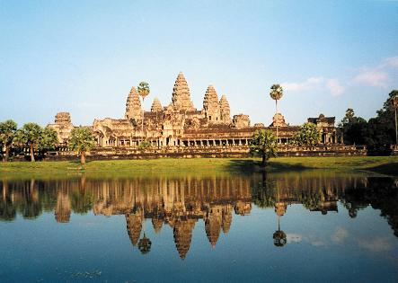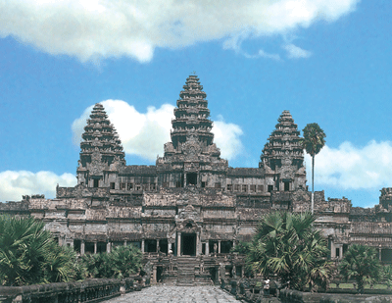

Tickets for the temple site are sold for either one, three or seven days. A one-day pass will give you enough time to see the main temples, whereas if you want to explore further sites it is definitely necessary to purchase extra days. You'll need a passport photo for your pass, but if you forget it there's a free photo service at the gate.
The celebrated temples of Angkor are Cambodia's greatest tourist attraction. The 100 or so temples are the sacred remains of what was once a much larger administrative and religious centre, and were built between the 9th and 13th centuries to glorify a succession of Khmer kings. Most of Angkor was abandoned in the 15th century and the temples were gradually cloaked by forest. The site became the source of scholarly interest in the late 19th century after the publication of Voyage à Siam et dans le Cambodge by French naturalist Henri Mouhot. Efforts were undertaken to clear away the jungle vegetation that threatened to completely destroy the monuments, and restoration continues today.
Apart from Angkor Wat, two other magnificent temples to visit are the Bayon and Ta Prohm.
The film Tomb Raider was shot at Angkor Wat.

Sihanoukville:
As tourism returns to Cambodia, Sihanoukville is finding itself on many a traveler’s itinerary. With its uncrowded beaches and ever-changing selection of bars and restaurants, it makes a great place to chill out for a few days.
If it's diving or snorkelling you want, Koh Pueh and Koh Koang Kang are the places to go. Idyllic islands of lush vegetation and green fringed beaches the waters here teem with life and are always crystal-clear.

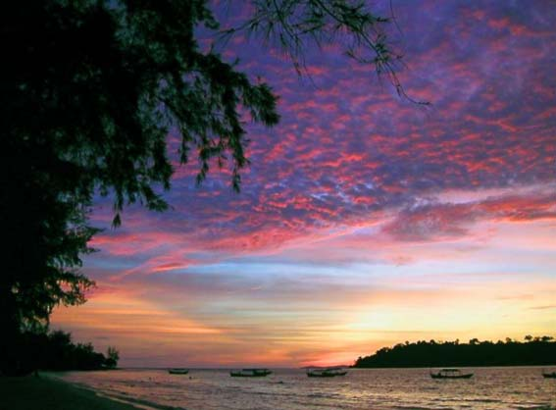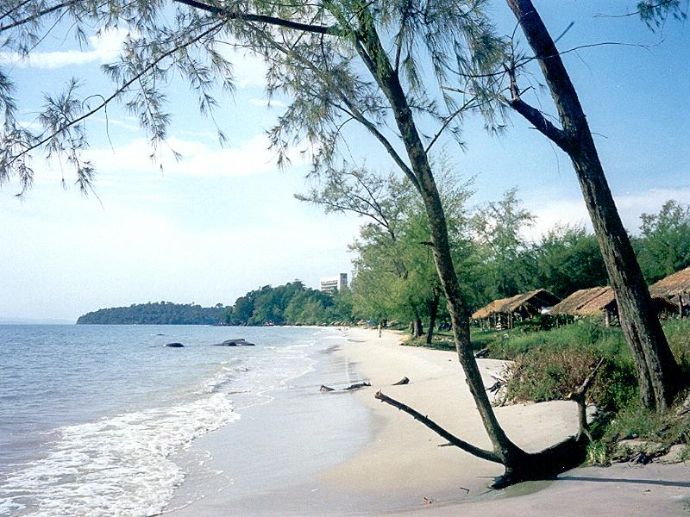

A boat from Sihanoukville takes about an hour to reach the closest beach. If you prefer your fish out of the water you can take a fishing trip, with charters leaving from the fisherman's port each morning. Back on the mainland, nearby Ream National Park offers a 21,000-hectare sanctuary of wetlands, undiscovered beaches and riverboat trips.

Bokor Hill Station:
Not far from Sihanoukville you'll find this interesting relic of French colonial times. During their years of rule, the French came to the cool heights of Bokor to escape the heat of the plains and to get away from it all - tantamount to a colonial theme park. Today, the old hill station, hotel and casino lie abandoned and crumbling, but it still makes for a fascinating trip. On a clear day, the views over the jungle are endless.
If the weather is hot a swim at the Popokvil waterfalls is the recommended way to cool off. The ranger station at the entrance to the surrounding national park provides accommodation and guides for extended visits.

Dolphin Watching at Kratie
For those that are passionate about wildlife, Kratie, north-east of Phnom Penh, provides a perfect opportunity to observe the endangered Irrawaddy freshwater dolphin in its natural habitat along the Mekong River.
The local dolphins are known to swim in small groups and, despite having a reputation for being shy, have a unique working relationship with Kratie's fishermen, driving fish into their nets. The fishermen, in return for a good catch, toss the dolphins a portion of the fish from the boat, ensuring that the dolphins keep coming back. Locals are often willing to hire out their boats to allow a closer look at these rare creatures.

BATTAMBANG:
Cambodia's second-largest city is an elegant riverside town, home to some of the best-preserved colonial architecture in the country. Until recently, Battambang was off the map for road travelers, but facilities have recently been improved and it makes a great base for visiting the nearby temples and villages. The network of charming old French shop houses clustered along the riverbank is the real highlight here, and there are a number of Wats scattered around the town. The small museum has a collection of Angkorian-era artefacts, and beyond the town, there are a number of hilltop temples and a large lake.
Despite being Cambodia's second largest city, Battambang is a relaxed, riverside town that has some of the finest French colonial architecture in the country.
The Sangker River runs through the town passing the large central market, which is surrounded by old-style French shops. Despite the prominence of colonial architecture today the atmosphere here is a lot less westernized than that of Phnom Penh, and you get a real sense of local town life in Cambodia.
Around Battambang the crumbling wats are being restored to their former glory following decades of neglect. Many of them date back centuries and are built in the distinctive Khmer style. The most popular include the ruined Wat Ek Phnom and Wat Banan, both easy day trips from the city. For many visitors the town functions as a jumping off point for tours with the surrounding countryside, one of the most accessible genuinely rural areas of the country, filled with paddy fields and terraces that provides the staple rice crop for the entire nation.

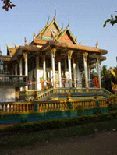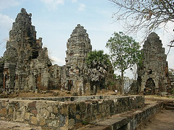

Ratanakiri Province:
Cambodia's north-eastern province borders with Vietnam and Laos and is home to some of the country's most ethnically diverse hill tribes, verdant rainforests and wildest wildlife.
This province suffered greatly from the US bombing campaign during the Vietnam War, which was followed by the rapacious forces of the Khmer Rouge. Today's threat comes from illegal logging, an incredibly serious but lucrative crime, which can descend into violence between the authorities and the outlaw lumberjacks.
The various hill tribes continue to live as they always have, practicing slash and burn farming and hunting with poison for their food. Tribal customs such as women tattooing their faces are still commonplace, and seeing these genuine tribes people is a far cry from the sanitized indigenous "theme-park" villages that are offered to tourists elsewhere. Jungle trekking, on foot or by elephant, and trips to the volcanic Crater Lake and waterfalls are among the highlights of this province.

SHOPPING:
Cambodia is known for good Silverware, textiles, wooden sculpture & stone carvings. The two main centers of Phnom Penh and Siem Reap are the best places to look for souvenirs. A uniquely Cambodian Souvenir that many visitors like to take home is the checked scarf made of cotton or silk known as KRAMA. In Phnom Penh some of the best markets are the Art Deco Psar Thmei, known as "Central" or "New Market", where everything is on offer from old coins to T-shirts, sarongs to cuts of pork. The Russian Market, Psar Tuol Tom Pong, is a better bet for souvenirs, with a range of jewellery, artwork, and antiques on offer. Silk making is a particularly highly prized skill. One of the best places to obtain silk is Koh Dach, near to Phnom Penh. Here you can see the traditional way of weaving coloured silk threads to create patterns in the completed fabric. With sizeable pieces taking a very long time - months in many cases - handwoven silk is quite expensive. Cambodian peppercorns have a reputation for being particularly fragrant and a considered a good buy.
Shops tend to open daily from 08h30 or 09h00 to 18h00. Smaller shops will normally close from around 11h00 for a long lunch (2-3hrs). Tourist stores normally keep longer hours. In smaller towns shops may keep erratic hours and may close for a specific day each week.

EVENTS:
Lunar New Year is celebrated by ethnic Chinese and Vietnamese in late January or early February. The Khmer New Year celebrations bring the country to a standstill for three days in mid-April - a fair amount of water and talcum powder gets thrown around at this time, so it's a lively time to visit. Chat Preah Nengkal, the Royal Ploughing Festival, takes place near the Royal Palace in Phnom Penh in early May. The Khmer calendar's most important festival is Bom Om Tuk, celebrating the end of the wet season in early November - it's the best time to visit Phnom Penh or Siem Reap. Banks, ministries and embassies are closed during all public holidays and festivals.

FOOD:
As in many Asian Countries, the staple food of the Cambodian diet is rice. This is usually served with dried, salted fish, chicken, beef or pork. Popular dishes include sam chruk, a roll of sticky rice stuffed soya bean and chopped pork, and amok, a soup of boneless fish & coconut spices. There are several Indian restaurants available also.

INDIAN RESTAURANTS IN CAMBODIA:

CITY | INDIAN RESTAURANT
Phnom Penh | Mount Everest Restaurant  N° 98AEo, Sihanouk (St. 274)  12302 Phnom Penh, Cambodia  Tel: 855-23 213 821
New Maharaja Restaurant
N° 11, Street 278, Near Golden Gate Hotel
12302 Phnom Penh, Cambodia
Mobile Phone: 855 11 921 115
Mobile Phone: 855 12 513 516
Flavors of India Restaurant
N° 158, Trasak Paem (St. 63)
12300 Phnom Penh, Cambodia
Tel: 855 23 990 455
Indian Curry Pot
N° 14, Street 93, Boeung Kak Lake
12201 Phnom Penh, Cambodia
Mobile Phone: 855 11 945 477
Indian Kitchen Restaurant & Bar
N° 162, Trasak Paem (St. 63), Near Lucky Super Market
12302 Phnom Penh, Cambodia
Mobile Phone: 855 12 692 344
Mobile Phone: 855 12 362 310
Sher-E-Punjab Bar & Restaurant
N° 16Eo, Khemarak Phomin (St. 130), off Riverside
12204 Phnom Penh, Cambodia
Tel: 855 23 992 901
Mobile Phone: 855 92 992 901
South India Restaurant & Bar
N° 1A, Street 93, Boeung Kok Lake
12152 Phnom Penh, Cambodia
Mobile Phone: 855 11 638 574
Mobile Phone: 855 12 316 370
Au Baba Indian Restaurant
N° 19BEo, Street 118
12204 Phnom Penh, Cambodia
Mobile Phone: 855 12 231 003
Mobile Phone: 855 12 644 202
Royal India Restaurant
N° 21, Street 111
12252 Phnom Penh, Cambodia
Tel: 855 23 300 080
Tel: 855 23 300 008
Mobile Phone: 855 12 855 651
Siem Reap | New Delhi Restaurant  N° 070, Module 1, Svay Dangkum Commune,  in front of Siem Reap Hospital  Siem Reap, Cambodia  Mobile Phone: 855 16 840 326  Mobile Phone: 855 12 758 253  Mobile Phone: 855 12 369 077
Taj Mahal Restaurant
N° 480, Group 6, Module 1, north Old Market
Siem Reap, Cambodia
Tel: 855 63 963 353
Mobile Phone: 855 12 859 866
Mobile Phone: 855 12 569 644
Mobile Phone: 855 16 948 225
Little India Restaurant
N° 363, Group 6, Module 1, Svay Dongkum Commune
Siem Reap, Cambodia
Mobile Phone: 855 12 652 398
Mount Everest Restaurant
N° 348, Sivutha Street
Siem Reap, Cambodia
Tel: 855 63 760 384
Mobile Phone: 855 12 965 522
Mobile Phone: 855 16 840 326
Curry Walla Restaurant
N° b05, Sivutha Street, in front of Mekong Bank
Siem Reap, Cambodia
Tel: 855 63 965 451
Mobile Phone: 855 92 746 325

DOS AND DON’TS:
- Remove your hat or scarf when talking with Buddhist monks. Naturally, they would forgive you the cultural faux pas, but it is respectful all the same.
- When bargaining for that "must-have" souvenir, remember that the few hundred riels you are haggling over are probably worth nothing to you but could make a very big difference to a Cambodian.
- As with many Asian countries, when giving or taking from another person, be sure to use your right hand as a mark of respect. The left hand is for ablutions.
- Tipping is not part of the local culture although many locals do their very best for tourists in all circumstances in the hope of making a few extra bucks. Consider leaving a small tip for staff, it can make a big difference to them.
- There are many amputees who have suffered the consequences of landmines and whose only income is through begging. It is part of Buddhist culture to give to those less fortunate, so do feel free to give if you feel it is right.
- Khmer people dress modestly and visitors would do well to follow their example. Do not wear skimpy clothing. Besides, long, loose clothing is more appropriate for the tropics.
- Don't point your feet at people or in the direction of Buddha.
- Don't pose next to statues of the Buddha for photographs. These statues are sacred and draping yourself around them is considered a definite no-no.

